Name:
Dawood Sarfraz

Roll no:
20p-0153

Section:
BSCS-9A

Assignment no 4:
Build Automation (Pre-Processors)

Submitted to:
Dr. Omar Usman Khan
1. Create a macro in the header file:
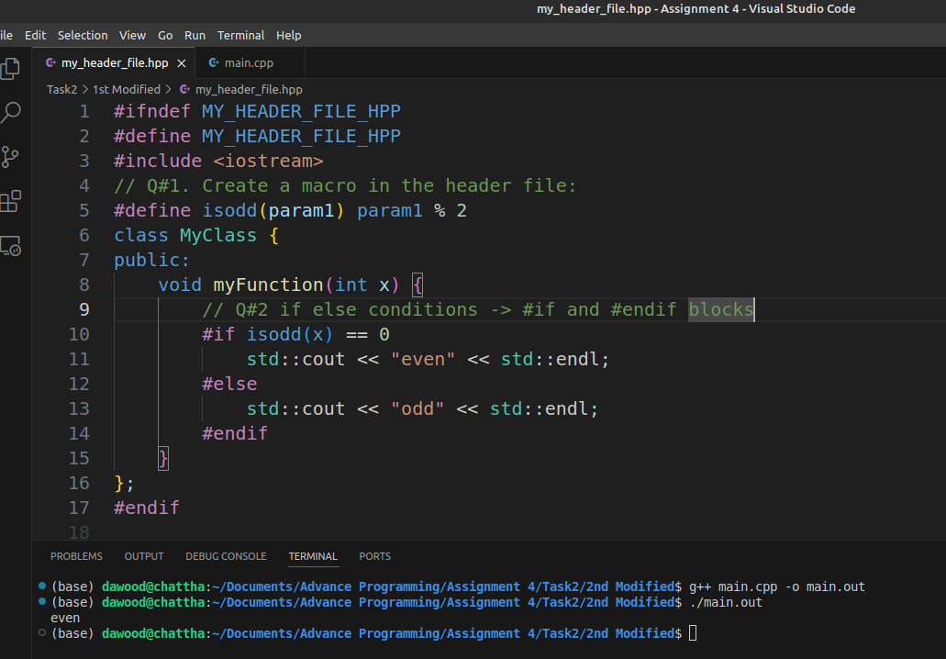
2. And modify the if else conditions to be included in respective #if and #endif blocks. Example is below:
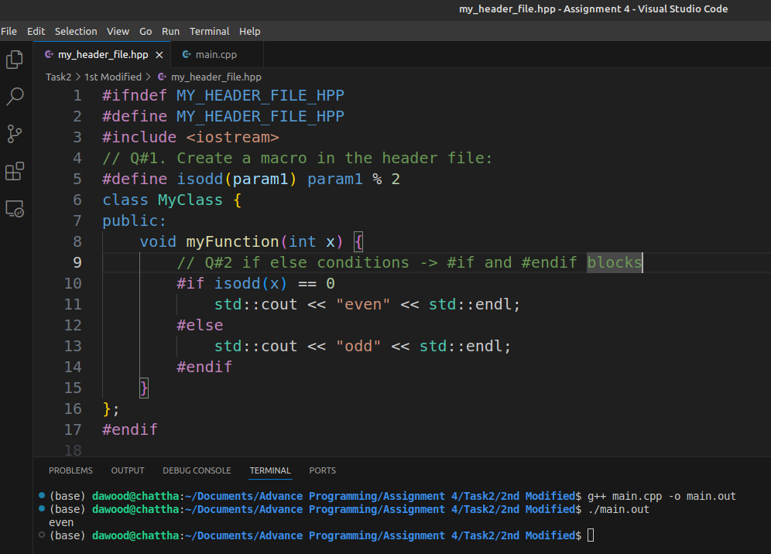
3. Is the code giving expected behavior? Think and comment about what the problem is
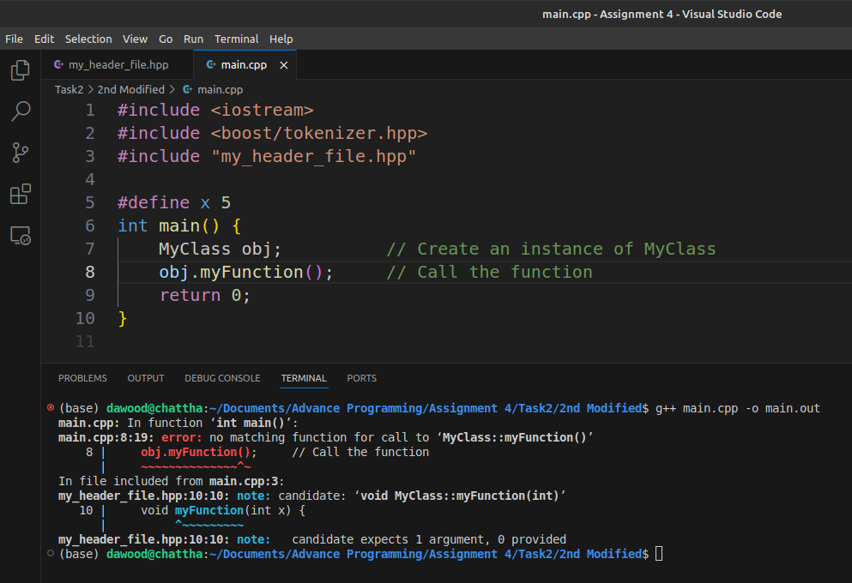
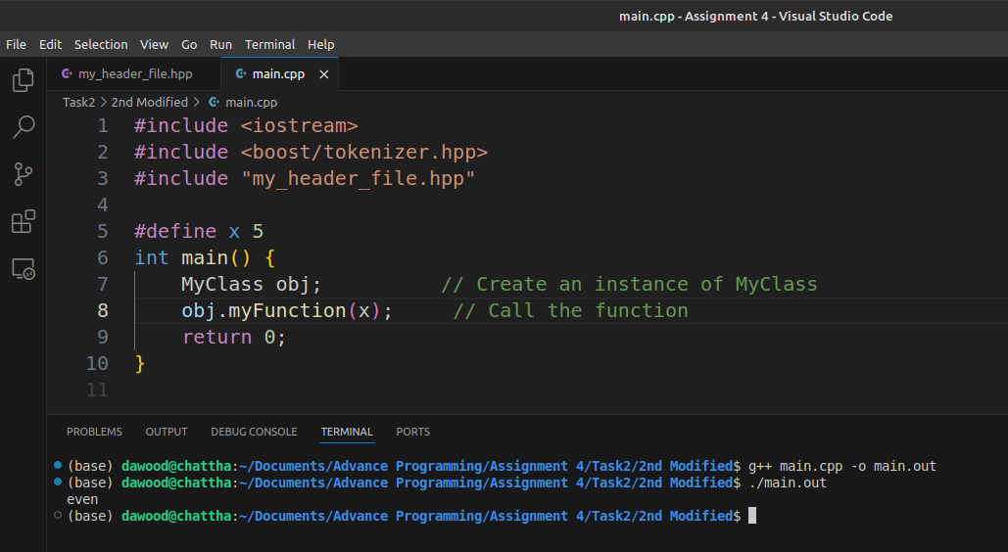
4. In the main file, modify obj.myFunction(5); to a compile-time variable as:
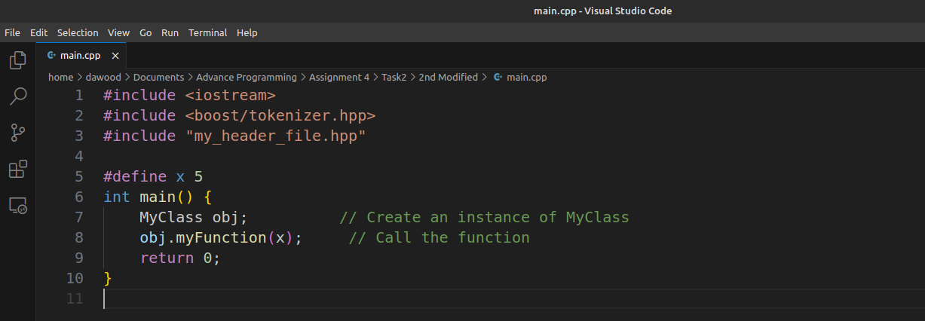

5. Is the code giving expected behavior? Think and comment about what the problem is.
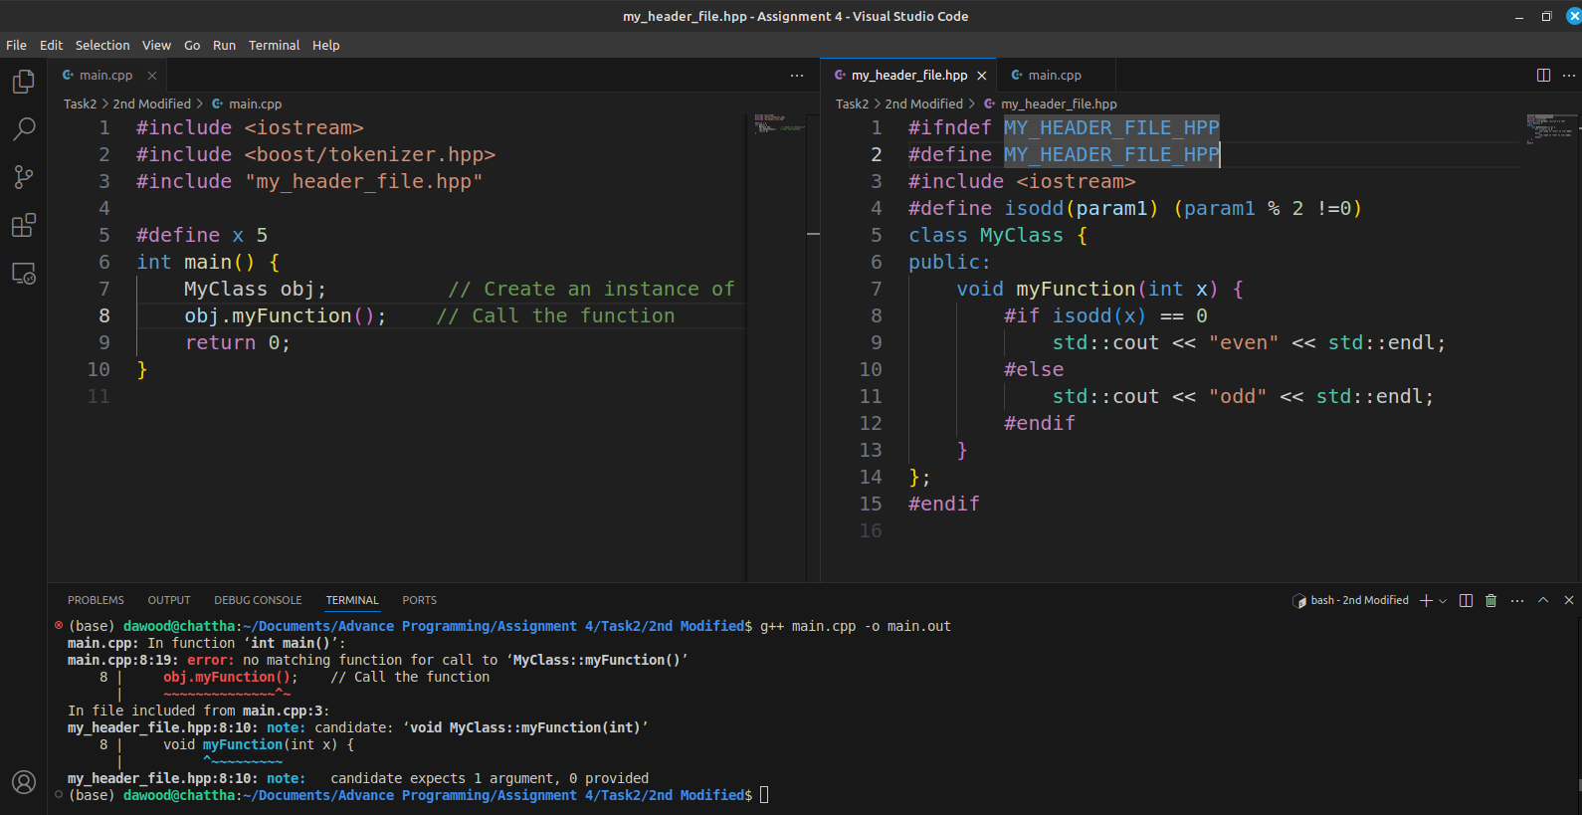

6. Now move the #define x 5 to the my_headerfile.hpp. Is the code giving expected behavior? Comment about the matter.
Ans:
With #define x 5 in the header file, the function will always treat x as 5,
printing "odd". This makes the code less flexible because x is now fixed.

7. Now delete the line #define x 5 even from my_header_file.hpp. And instead, run this command as:
Ans:
The code should work as expected, printing "odd" since x is defined as 5 at compile time through the compiler option.

8. Is the code giving expected behavior?

